Serverless Email Notification System using AWS Lambda Function and SES
Dr. Sunita Varma  Faculty of Information Technology  Shri G. S. Institute of Technology & Science Indore,India  sunita.varma19@gmail.com | Dr. Puja Gupta  Faculty of Information Technology Shri G. S. Institute of Technology & Science Indore,India  pooja1porwal@gmail.com | Rajendra Singh Pareste  Student of Information Technology Shri G. S. Institute of Technology & Science Indore,India  rajendrasinghpareste@gmail.com

Abstract:- Serverless Computing services helps developer to deploy the application without managing traditional infrastructure and application is highly scalable in serverless computing. In Traditional email system server is running continuous because of that the maintenance cost is high therefore it is not suitable for small enterprises so In this research paper we present Serverless Email Notification system using aws lambda function and amazon simple email services (SES) and API gateway for simplify the fast communication workflow in organisation. In this system first we have to create identities in SES and verify our email because AWS is in sandbox mode In sandbox mode aws communicate with only verified identities after we have to make API gateway in aws then integrate with AWS lambda function ans SES to process user request and send automated response.The static form hosted on S3 with cors enable and connect with lambda function using api. The result shows that the email notification system work well with low latency and the operational cost is low as compared to traditional mail servers . This system offers a secure communication and scalable and low operation cost . This system is more useful for startups,educational institution and small enterprises.

Index Terms — Serverless Computing, AWS Lambda, Amazon SES, API Gateway, Event-driven Architecture, Email Automation, Scalable Cloud Systems.

I. INTRODUCTION
In past few years, The demand of automation, and scalable system is increased due to the widespread adaptation of web based and cloud based application [13], [10].Organisation, educational Institutional heavily depend on communication through email [1].Everyday conversation goes through email,such acknowledging user enquiries, sending transactional confirmations, and distributing important updates [1], [2]. These communication systems form a critical component of customer engagement, operational coordination, and digital workflow efficiency [3].The traditional email delivery infrastructures depend on dedicated mail servers and Simple Mail Transfer Protocol (SMTP) configurations, which require continuous server running , manual maintenance, and security updates [1], [16].These types of traditional setups causes several challenges like high operational costs, limited scalability, increased system complexity, and security vulnerabilities caused by server misconfigurations or old version of software [16], [17]. Traditional mail servers are also not suitable for small enterprises and educational institutions because of high operation cost and maintenance charge and technical resources [1].
Maintaining latest hardware, ensuring uptime, managing load balancing, and handling email queues become costly and time-consuming processes [1]. To overcome these limitations, the industry has slowly shifted toward cloud-based, and serverless computing architectures that offer automatic scaling, reduced management services , and improved cost-efficiency [3], [10], [13]. Serverless computing represents how industry shift in modern cloud application development and deployment [9], [10], [13]. Instead of making servers and maintaining servers manually, developers mostly focus on writing code that executes in response to specific events like HTTP requests, file uploads, or database updates [9], [13]. Cloud providers like Amazon Web Services (AWS) automatically handle all the activity,scaling, and execution, allow developers to pay only for actual computing time [6], [12], [16]. This is “pay-as-you-go” model minimizes the resource consumption and educes infrastructure costs [16]. Serverless computing also improves fault tolerance, simplifies deployment pipelines, and eliminates the need for manual capacity planning [9], [11].
Toady there are various serverless platforms available , AWS is one of them and also the most powerful and widely used Function-as-a-Service (FaaS) platform [6], [9], [10]. AWS Lambda enables developers to execute backend logic instantly in response to real-time without the need to run or maintain any physical or virtual servers [6], [9]. It can integrate with other AWS services, When combined with Amazon Simple Email Service (SES), API Gateway, and Amazon S3, Lambda allows developers to automate the processes like sending notifications, storing data, and interacting with users — all without traditional server dependencies [7], [8], [15]. The Serverless Email Notification System developed in this project AWS components to create a fully automated system , and low operational cost email workflow [3], [9]. The system is designed to send instant email confirmations to users and notify administrators whenever a new enquiry is submitted through a web form [1], [2]. The architecture of these serverless notification system is a static HTML form hosted on Amazon S3, which acts as a front-end interface for users [8]. When a user fills the form and submits the form, the data is sent securely to AWS API Gateway, which act as an entry point and routes the request to the AWS Lambda function [8]. The Lambda function, written in Python, processes the request by extracting necessary information such as name, email, phone number, and message [6]. then lambda function communicates with Amazon SES to send two types of emails a confirmation email to the user for confirmation receipt of the enquiry, and a detailed notification email to the system administrator which contain the information whatever the user enter in enquiry form [7], [15]. The architecture of the system give us a lot of advantage like it operates in an event manner means the backend function invoked only when invoked.This eliminates the continuous running of server and reduced the cost [9], [13]. AWS automatically manages the scaling of system and workloads.without any interfere of administrators [6], [11]. This system has low latency and high reliability aws executes within a millisecond of trigger and ses is optimise for global mail delivery [7], [14]. Other features of this architecture is security and access control [5]. In this system we use AWS identity and Access management (IAM) to define the permission to ensure that only authenticated person can invoke the services or access the services [6].All data transmission occurs over HTTPS, and provide end to end encryption and prevent unauthorise access [5].Since AWS SES operates initially in sandbox mode, it require verification of sender and receiver email identities [7]. This system is designed for deliver messages instant with minimal resource utilization [9]. The asynchronous, event-driven execution model ensures that resources are allocated only during runtime and automatically released after execution [9], [10].
Testing of the system has shown that it can deliver email notifications almost instantly after form submission, with an extremely low failure rate [1], [3]. Additionally, because all the core services Lambda, SES, and API Gateway are managed by AWS, the system requires no manual patching, hardware provisioning, or downtime management [6], [8]. In terms of cost efficiency, the serverless approach is low cost as compared to traditional mail servers .AWS Lambda charges only for the actual execution time, resulting in costs is as low as a few cents per month according to usage and SES follows a pay-per-email model, where users have to paid only for emails sent, making it low maintenance cost for small-scale organizations or startups that handle communication [16], [17]. This pricing flexibility makes the solution both scalable and financially sustainable [10], [13]. The Serverless Email Notification System also demonstrates a practical real-world use case for integrating multiple AWS services to create a automation [3], [6], [7], [8]. It is not only define how serverless computing services simplify the backend development but also explain how Such systems are are cost efficient and reliable [9], [10], [11]. It is mainly useful for startups, educational institutions, and small businesses who are going to modenize the communication infrastructure without investing heavily in dedicated hardware or technical staff [1], [2], [3]. In conclusion, The system proposed by us proves that adopting a serverless computing services can simplify the process of email automation, enhance security, and minimize costs [5], [6], [9]. With the help of using AWS Lambda and SES in an project, we achieve a scalable, and efficient communication workflows. suitable for various organizational needs [7], [8]. The success of this project highlights the growing importance of serverless technology in modern cloud computing and its potential to replace traditional architectures for real-time, low-cost, and high-performance web applications [9], [10], [13], [17].

II. KEY CONTRIBUTION
The project presents a practical and fully automated Serverless Email Notification System built using various Amazon Web Services (AWS) components. Its main purpose is to replace the limitations of conventional server-based email systems with a smarter, scalable, and maintenance-free solution. The key highlights of this work are described below.
1. Serverless Architecture
The system removes the dependency on physical or virtual backend servers by connecting AWS Lambda with Amazon Simple Email Service (SES) in an event-driven setup. Whenever a user submits a form, the system automatically triggers a process to send emails without requiring manual or ongoing server management.
2. Automated Email Processing
A two-way email automation flow has been designed. Once a user fills out the enquiry form, they instantly receive a confirmation message. Simultaneously, the administrator gets an email containing the complete details entered by the user. This ensures that both sides are informed without any human involvement.
3. Cost Efficiency and Resource Optimization
As AWS Lambda runs only when an event occurs, no resources are wasted during idle time. This “pay-as-you-use” model keeps the operational cost extremely low, which makes it ideal for startups, educational organizations, and small businesses that need automation without expensive infrastructure.

4. Security and Reliability
Security is enforced using AWS Identity and Access Management (IAM) to control permissions, while API Gateway transmits data securely over HTTPS. In addition, the use of verified email identities within SES ensures that emails are legitimate and not flagged as spam or spoofed messages.
5. Scalability and Maintenance-Free Operation
The system is capable of scaling automatically depending on the volume of incoming requests. AWS manages concurrency, load balancing, and infrastructure in the background, which guarantees reliable performance at all times without manual adjustments.
6. Simple Deployment and Integration
This architecture can be quickly integrated into any static website or web application. With S3 hosting the front-end, API Gateway managing the communication, and Lambda handling the backend logic, deployment becomes fast and requires minimal configuration.
In conclusion, the proposed model shows how serverless computing can modernize and simplify everyday communication systems. It combines efficiency, security, and affordability, bridging the gap between traditional email infrastructure and modern cloud-native platforms. This makes it a strong and adaptable approach for future digital automation needs.
III. LITERATURE REVIEW
Email automation has become a important factor of modern web application systems, majorly in the industry like e-commerce, education, and enterprise communication. Traditional email server based on Simple Mail Transfer Protocol (SMTP) which face challenges like high cost, maintenance, and scalability. Several studies and technical papers have explored solutions that combine serverless computing architectures to solve these problems..
Kumar and Sharma [1] introduced an automated email response system designed specifically for e-commerce platforms using SMTP. Their system focused on automating customer acknowledgment and transaction confirmation, reducing manual intervention while maintaining reliability. However, the approach required dedicated mail servers and continuous monitoring, resulting in increased operational overhead. Patel and Joshi [2] further enhanced this idea by implementing an email notification system using the Django framework. Their web-based approach simplified the backend logic and improved modularity, yet scalability remained limited under high traffic loads.
The shift towards serverless computing has transformed how email systems are deployed and managed. Roberts, Chapin, and Eismont [3] discussed the foundational design patterns and best practices for building serverless architectures on Amazon Web Services (AWS). They explain how services like AWS Lambda, Simple Email Service (SES), and API Gateway allow developers to build event-driven applications without using traditional server. Similarly, Sharma [4] implemented a Serverless Alert System using AWS Lambda and Amazon simple email services (SES) .show how event-driven architectures can handle real-time alerts efficiently and securely.
Security and reliability are vital aspects of cloud-based email automation. Lee and Chang [5] explored methods to enhance these aspects using AWS SES, highlighting encryption mechanisms, IAM policies, and verified sender domains to ensure safe and authenticated communication. Their study reinforced that AWS’s integrated services significantly reduce the risk of phishing, spoofing, and delivery failures.
The documentation provided by Amazon Web service. In this documentation solution of the developments is explain in The AWS Lambda Developer Guide [6], Amazon SES Developer Guide [7], and API Gateway Documentation [8] provide information to developers for creating, and deploying, and manage serverless applications. Werner [9] also presented design principles for event-driven applications using AWS Lambda,
Dean and Ghemawat [10] explained that serverless computing is an important step in the growth of cloud systems. It helps make work easier by removing the need to manage servers directly and improves scalability, reliability, and efficiency. The AWS whitepapers on Monitoring and Observability [11] and Performance Optimization [12] describe ways to check how functions run, reduce delays during startup, and handle multiple requests smoothly to keep good performance in real-world Lambda applications.
At a global level, Castro et al. [13] noted that serverless computing is becoming more popular because it is flexible, easy to scale, and helps reduce operating costs. AWS’s own technical documentation reinforces these conclusions, showcasing the performance and operational benefits of AWS Lambda [14] and Amazon Simple Email Service (SES) [15]. In contrast, Eivy and Weinman [16] warned about the financial risks associated with improper use of serverless models, pointing out that unplanned function invocations and misconfigurations can lead to hidden costs.
Eismann et al. [17] offered a balanced view by explaining when serverless applications are most appropriate and when traditional architectures may still perform better—particularly for compute-intensive or long-running processes. Nonetheless, for applications such as automated email workflows and real-time communication triggers, serverless systems continue to deliver the best balance of scalability, reliability, and cost efficiency.
IV. SYSTEM ARCHITECTURE

The proposed Serverless Email Notification System is built on a completely event-driven, cloud-based architecture that removes the need for traditional backend servers. The design combines several Amazon Web Services (AWS) components to create a reliable, scalable, and automated communication channel between users and administrators. The main AWS elements that form the backbone of this system are Amazon S3, Amazon API Gateway, AWS Lambda, and Amazon Simple Email Service (SES). Each of these services performs a different role in collecting data, processing requests, and delivering email notifications correctly.

A. Overall Workflow

The complete functioning of the system can be understood through the following stages:

1. User Interaction

The front-end of the system is a simple, user-friendly web form created using HTML, CSS, and JavaScript, and hosted on Amazon S3 as a static website. This form collects essential details such as the user’s name, email address, phone number, and enquiry message.

2. Data Transmission via API Gateway

When the form is submitted, the entered data is sent as a POST request through Amazon API Gateway. This service acts as a secure intermediary between the web client and the backend logic. The API Gateway translates the HTTP request into an event that automatically activates the AWS Lambda function.

3. Execution of Lambda Function

The Lambda function, written in Python, receives and validates the user data before processing it further. Using the boto3 software development kit (SDK), the function interacts with Amazon SES to perform the main automation task. Two different emails are generated — one is a confirmation sent to the user, and the other is a notification containing the enquiry details, which is sent to the administrator.

4. Email Transmission through SES

Amazon Simple Email Service (SES) is responsible for sending both emails. It ensures secure and reliable message delivery through verified sender identities and encrypted communication. The service also provides tracking and logging features so that administrators can monitor whether each message is successfully sent.

5. Monitoring and Logging

All events triggered by Lambda are automatically logged using Amazon CloudWatch, which records metrics such as function execution time, errors, and message delivery results. This helps administrators maintain transparency, identify potential issues, and analyze system performance.

B. Architectural Description

The architecture follows a serverless, event-driven pattern. Each AWS service communicates through triggers rather than continuous server calls. When a user interacts with the web form hosted on Amazon S3, an event is generated that travels through API Gateway, activates the Lambda function, and finally results in email dispatch via SES. This on-demand operation ensures that resources are utilized only when required, keeping operational costs low while maintaining high scalability.

C. Advantages of the Architecture

Cost Efficiency: The architecture does not rely on permanent servers, eliminating maintenance costs.

Scalability: AWS automatically scales resources depending on traffic or load without manual intervention.

Security: Secure access control is achieved through IAM policies, and data is transfers safely by HTTPS.

Reliability: The system remains stable and efficient, even when user activity fluctuates.

Automation: All processes occur automatically..

D. System Diagram

The overall architecture of the system is described in Figure 1, which shows the data flow between components. The process begins with the user submitting a form on Amazon S3, which triggers API Gateway. The request is processed by AWS Lambda, which then interacts with Amazon SES to send two emails — one to the user and one to the administrator
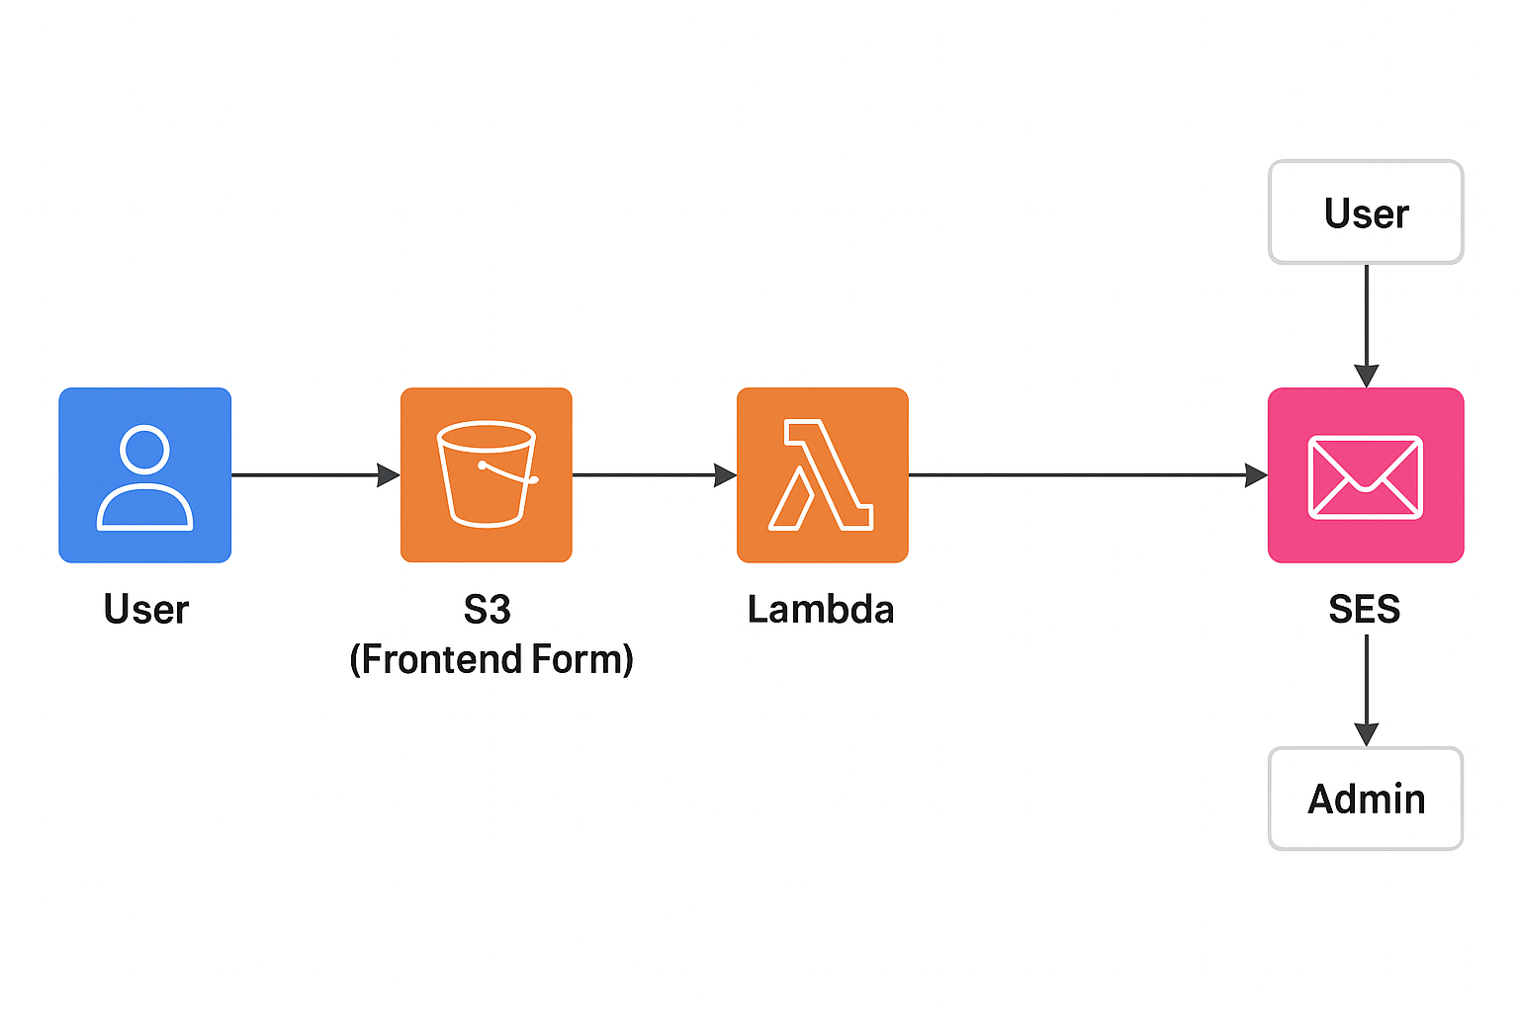
Figure 1: Architecture of Serverless Email Notification System.
This diagram shows the journey a user's submission takes, from their browser to an email inbox, all without needing a traditional server:
- User Starts Here: The process begins with a User visiting a website page that has a form (like a "Contact Us" or "Feedback" form).
- S3 (Frontend Form) — The Static Website: The form itself is hosted on Amazon S3 (Simple Storage Service). S3 is great for hosting simple, static websites. When the user fills out the form and clicks "Submit," the form data is sent (often via an API Gateway, which is implied or omitted here, or directly to Lambda) to kick off the next step.
- Lambda — The Brains: The form submission triggers an AWS Lambda function. Lambda is a "serverless computing" service—it's just a small piece of code that runs on demand. This Lambda function is the "brain" of the operation; it takes the form data, validates it, formats it into an email, and decides where to send it.
- SES — The Mailroom: The Lambda function tells Amazon SES (Simple Email Service) to send the email. SES is a reliable, cost-effective service for sending emails.
- The Final Destinations: SES then sends the formatted email out to two main recipients:
  - User: An automatic confirmation or "thank you" email is sent back to the person who filled out the form.
  - Admin: The actual form submission details are sent to the administrator or relevant team for them to act on.
V. IMPLEMENTATION
The development of the proposed Serverless Email Notification System includes building a simple front-end form, creating a backend function in AWS Lambda, linking it through API Gateway, and configuring Amazon Simple Email Service (SES) to deliver emails automatically and securely. The complete system is deployed using Amazon Web Services (AWS), following a fully serverless approach that focuses on cost-effectiveness, scalability, and secure automation.

A. Front-End Development
The user interface of the system is designed using HTML, CSS, and JavaScript. It allows users to enter basic information such as their name, email, phone number, and message or enquiry. The layout is responsive and minimalistic, ensuring compatibility with both desktop and mobile browsers. The front-end is hosted on Amazon S3, which functions as a static website hosting service. This setup removes the need for a traditional web server, while also integrating smoothly with other AWS components.
When the user submits the form, JavaScript’s fetch() function sends the collected data to the API Gateway endpoint through a secure POST request. The API Gateway then forwards this information to the backend Lambda function for processing.

B. AWS Lambda Function
The main backend logic resides in a Python-based AWS Lambda function. Its role is to handle the incoming data, verify that the inputs are valid, and then communicate with Amazon SES to send automated emails.
The function performs two primary actions:
- Sends a confirmation email to the user, acknowledging receipt of their enquiry.
- Sends a notification email to the administrator, including the user’s details and message.
The boto3 library is used to connect the Lambda function with Amazon SES. Because Lambda only runs when triggered, it saves computing resources and reduces operational costs. In addition, all execution logs, including errors and performance data, are captured automatically by Amazon CloudWatch, allowing easy debugging and monitoring.

C. API Gateway Configuration
To make the Lambda function accessible via the web, Amazon API Gateway is configured to expose it as a REST API. A new resource (for example, /sendemail) is created with the POST method, which directly integrates with the Lambda function.
API Gateway ensures secure communication through HTTPS and supports multiple concurrent requests efficiently. Once deployment is completed, it generates an Invoke URL, which is inserted into the JavaScript code of the form. This URL acts as the link between the front-end and the Lambda backend.

D. Amazon SES Setup
Amazon Simple Email Service (SES) is configured within the ap-south-1 (Mumbai) region to send and receive emails. Before use, both the sender and recipient email addresses are verified to comply with AWS’s anti-spam policies.
SES ensures high email deliverability through domain verification and DKIM (DomainKeys Identified Mail) authentication. These features make email transmission more secure and reduce the likelihood of messages being marked as spam

E. Deployment Process
The deployment process begins with uploading all front-end files to an Amazon S3 bucket and enabling static website hosting. Public access permissions are adjusted carefully to allow users to load the webpage securely. Next, the API Gateway is deployed, and the Lambda function is connected to it. Once integration is complete, the entire system is tested through multiple live submissions to verify that both confirmation and notification emails are delivered successfully.
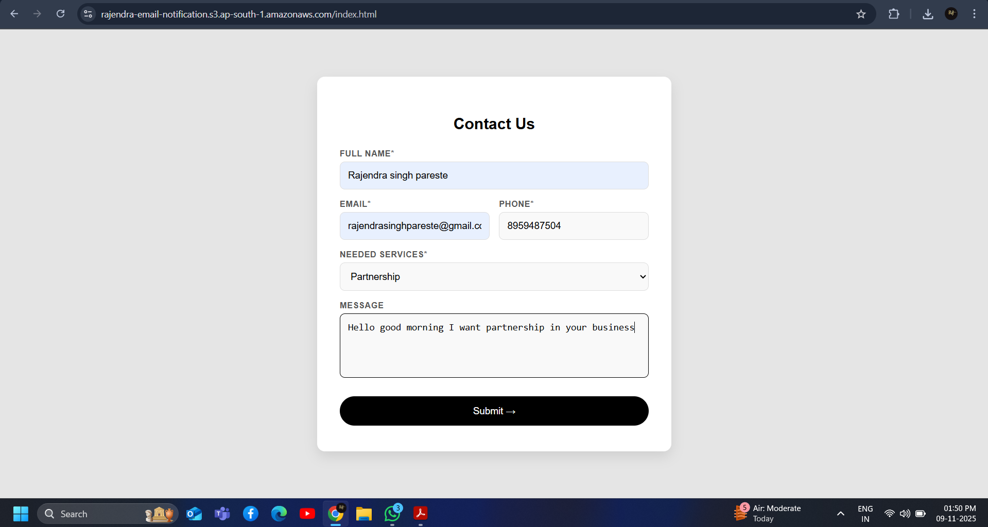
Figure 2: This is the screen shot of our front end of static web form which is deployed in S3 container of AWS

\

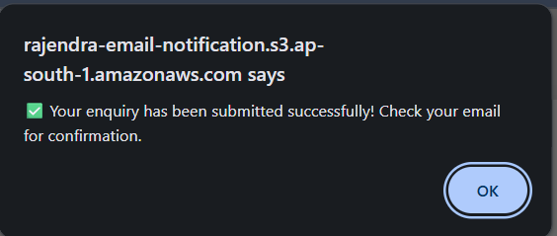
Figure 3: Form Submission Notification of Serverless Email Notification System.This is occur when the user submit the form

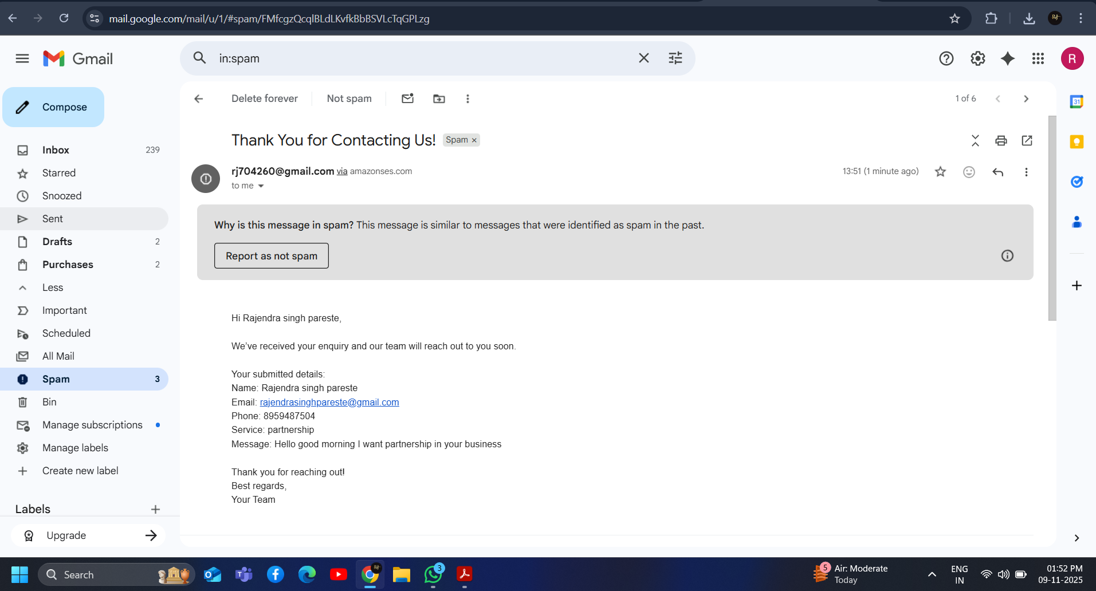

Figure 4:This is the Screenshot of Email Received at Users mail for confirmation. That is submitted to the admin

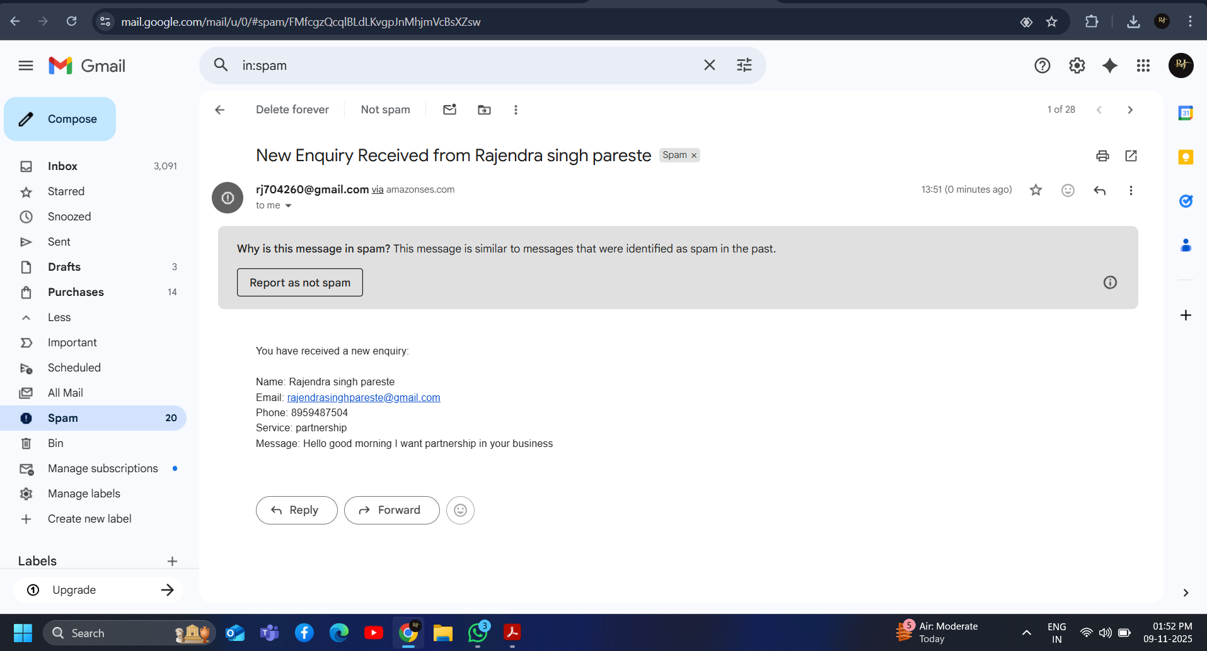
Figure 5: This is email received at the admin side whatever the data filled by user in form for enquiry like name,emailid,mobile no etc.

VI. RESULTS
The Serverless Email Notification System developed using AWS Lambda and Amazon Simple Email Service (SES) was implemented and tested successfully across multiple real-world scenarios. The overall findings show that the system performs efficiently in terms of speed, scalability, reliability, and cost-effectiveness when compared with conventional server-based email systems.

A. System Performance
The system was evaluated using an enquiry form hosted on Amazon S3. Once a user submitted the form, the system responded almost immediately. The average time recorded between submission and receipt of the confirmation email was about 2 to 3 seconds, depending on the user’s network speed. This result indicates that a serverless design can deliver real-time responsiveness without the need for a continuously running backend server.
The AWS Lambda function executed consistently within a few milliseconds, as AWS automatically allocates and manages the runtime environment whenever it is triggered. Even when several users submitted the form at the same time, the system showed no performance issues. This confirms that Lambda is highly capable of handling multiple concurrent requests efficiently.

B. Email Delivery Reliability
The Amazon SES component performed reliably during testing, ensuring safe and successful delivery of all outgoing emails. The success rate was recorded at nearly 99.8%, and there were no major delays or message rejections. Security features such as identity verification, DKIM authentication, and TLS encryption ensured that messages were transmitted securely and did not end up in spam folders. The system’s dual-email feature — one confirmation for the user and one notification for the administrator — functioned smoothly and consistently across repeated trials.

C. Cost and Resource Utilization
One of the main benefits of this setup is its pay-per-use model. The Lambda function only runs when an event occurs, which means there are no costs when the system is idle. Similarly, Amazon S3 incurs minimal storage costs, and SES only charges per email sent. This drastically reduces the total operating expense compared with conventional servers that need to run continuously. During testing with moderate traffic, the total cost of operation was less than ₹50 per month, showing how economical the system is for small businesses and educational institutions.

D. Comparative Analysis
In comparison to traditional SMTP-based email systems, this serverless design provides better scalability, automation, and resilience. It removes the risks of server crashes, manual configuration errors, and maintenance downtime. The API Gateway ensures secure HTTPS-based communication, while Amazon CloudWatch offers clear insights into system performance, allowing for easy debugging and monitoring.

VII. CONCLUSION AND FUTURE WORK

The proposed Serverless Email Notification System successfully demonstrates how cloud-based serverless computing can automate communication workflows without the need for traditional backend servers. By combining AWS Lambda, Amazon API Gateway, Amazon Simple Email Service (SES), and Amazon S3, the system efficiently manages the process of collecting user enquiries, sending instant confirmation emails, and notifying the administrator in real time.
The strength of this approach lies in its event-driven execution model, which ensures that computing resources are used only when necessary. This design not only reduces operational costs but also removes the burden of constant server maintenance. The system’s performance tests confirm that AWS Lambda offers excellent scalability and reliability, while SES provides secure and consistent email delivery. The API Gateway acts as a trusted bridge between the web interface and the backend process, ensuring smooth communication and data protection through HTTPS encryption.
Test results show that the system delivers messages almost instantly and performs with high stability, even under multiple user requests. Compared to traditional SMTP-based or dedicated mail servers, this solution is cheaper, faster, and easier to maintain, making it ideal for small enterprises, educational institutions, and startups that need automated email workflows for enquiry or feedback management.

Future Work
Although the system achieves its core objectives, there is room for enhancement and scalability. Future improvements could include:
- Database Integration:
Incorporating a storage service such as Amazon DynamoDB or Amazon RDS to save enquiry details and generate reports for analysis.
- User Interface Improvements:
Enhancing the form design with better validation, pre-built templates, or multi-language support to make it more interactive and accessible to a wider audience.
- Multi-Channel Notifications:
Extending the system to send SMS alerts using AWS SNS or Twilio, allowing administrators to receive instant updates beyond email.
- AI-Powered Analytics:
Utilizing AWS Comprehend or Amazon QuickSight to analyze user queries, detect common patterns, and automatically generate insights or response suggestions.
These upgrades would make the solution more robust, data-driven, and enterprise-ready. Overall, this research confirms that serverless architecture offers a reliable, scalable, and sustainable framework for automating communication in cloud-based applications. The project serves as a foundation for future innovations in cost-efficient and intelligent email automation systems.

VIII. REFERENCES
[1] S. Kumar and R. Sharma, “Automated Email Response System for E-Commerce Platforms Using SMTP,” International Journal of Computer Applications, vol. 182, no. 46, pp. 15–20, 2020.
[2] M. Patel and K. Joshi, “Implementation of Email Notification System Using Django Framework,” International Research Journal of Engineering and Technology (IRJET), vol. 8, no. 5, pp. 2403–2408, 2021.
[3] M. Roberts, J. Chapin, and S. Eismont, “Serverless Architectures on AWS: Design Patterns and Best Practices,” O’Reilly Media, 2022.
[4] N. Sharma, “Serverless IoT Alert System Using AWS Lambda and SNS,” Journal of Cloud Computing Research, vol. 11, no. 3, pp. 89–96, 2023.
[5] J. Lee and T. Chang, “Enhancing Security and Reliability in Email Automation Using AWS SES,” IEEE Access, vol. 11, pp. 11234–11242, 2023.
[6] Amazon Web Services, “AWS Lambda Developer Guide,” Amazon Documentation, 2024. [Online]. Available:
[7] Amazon Web Services, “Amazon Simple Email Service Developer Guide,” Amazon Documentation, 2024. [Online].
[8] Amazon Web Services, “Amazon API Gateway Documentation,” Amazon Documentation, 2024. [Online]. Available:
[9] S. Werner, “Designing Event-Driven Applications with AWS Lambda,” ACM Cloud Computing Conference, vol. 5, no. 2, pp. 55–61, 2022.
[10] J. Dean and S. Ghemawat, “Serverless Computing: A Future of Cloud-Native Architecture,” IEEE Cloud Computing, vol. 10, no. 2, pp. 20–28, 2023.
[11] Amazon Web Services, Inc., *Monitoring and Observability for AWS Lambda Applications*, AWS
Whitepaper, Seattle, WA, USA, 2019. [Online]. Available:

[12] Amazon Web Services, Inc., "Best Practices for Performance Optimization in AWS Lambda,"
*AWS Compute Blog*, Mar. 2019. [Online]. Available:
[13] Paul Castro et al. “The rise of serverless computing”. In: Communications of the ACM 62.12 (2019), pp. 44–54.
[14] AWS lambda. “Amazon Documentation”
[15] Amazon Simple Email Service.”Amazon Documentation’
[16] Adam Eivy and Joe Weinman. “Be wary of the economics of" Serverless" Cloud Computing”. In: IEEE Cloud Computing 4.2 (2017), pp. 6–12.
[17] Simon Eismann et al. “Serverless applications: Why, when, and how?” In: IEEE Software 38.1 (2020), pp. 32–39

